# CREATING ATTRACTION ZONES

**Lab 5B: Place an Attraction Zone: Operator Level control station**

1. Activate Pinpoint 
2. Select the place volume by two points command 
3. Name the volume Control1
4. Set Type to: Pipe Attraction  
   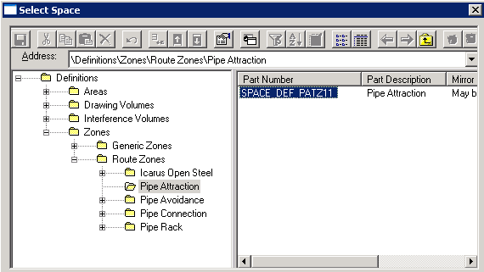
5. Set Space folder to Attraction Zones  
   
6. Define start point at E 14m, N 49.5m, EL 0.5m in the Layout coordinate system
7. Define end point at E 17m, N 50.5m, EL 1.5m in the Layout coordinate system  
   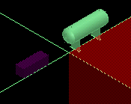

# USING ATTRACTION ZONES AND LIMIT PATH COMMAND

**Lab 5C: Using Limit Path to bring a line route down to control station level**

1. Modify the **Layout** filter to use the EquipmentZones space folder which contains the piperack’s volumes:  
   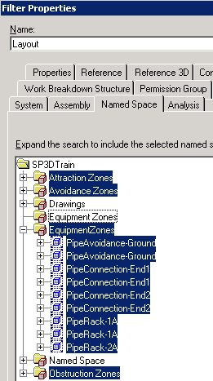
2. Activate the Limit Path command  (Notice the prompts to be followed on the bottom left of the SP3D window)
3. In the workspace explorer select the 4in piperun under P1 just defined
4. Accept the piperun using  in the bar menu
5. Select the volume **Control1** just created by clicking on it on the screen
6. Select **Finish** on the bar menu to accept and finish the command
7. Select the Automatically Route command 
8. In the Pipe Runs tab, scroll to the right and review the Vias Count value. Notice the 1, which indicates the line must pass through the attraction zone just selected

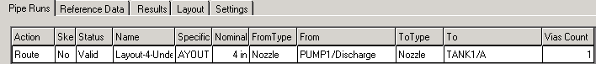

1. Select the preview option 
2. Review the results. Decide if the proposed layout is adequate, or relocate the attraction zone with the move command to improve the layout (Cancel out of the autoroute command before using move). In this example, the proposed route runs through the middle of the horizontal vessel, creating a severe clash (possibly a bug, since equipment bodies are supposed to be an avoidance zone):  
   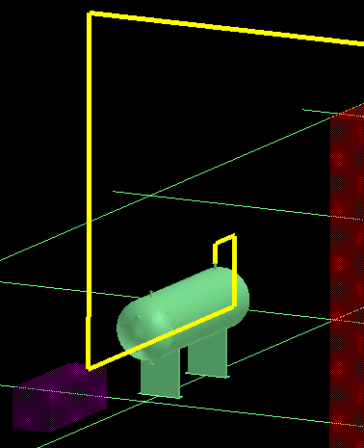
3. Moving the control station attraction zone to the other side of the vessel results in the following layout:  
   